Water consumption
Learn how mathematicians predict UK's future water usage

Subject(s): Science, Design & Technology, Mathematics  Approx time: 2 x 60 mins |  |  | Key words / Topics:  - estimate  - manipulate numbers  - complex data  - spreadsheet
Suggested Learning Outcomes
- To analyse and interpret a wide range of data
- To gain understanding of mathematical modelling used in the real world to predict unknowns
- To use the mathematical understanding of the students to review, recreate, and possibly improve mathematical information presented by a Water Board.
Introduction
This activity continues the theme of water usage developed in the Sewage Tunnels activity but can be delivered independently should the teacher wish. Students estimate how much water they use each day and apply their mathematical understanding to interpret a wide range of complex data to develop their appreciation of why water usage is such an important issue. Finally, students create a spreadsheet to support others in estimating how much water someone uses.

Purpose
This activity provides an engaging lesson, focusing on the link between the UK’s current water usage and the predicted increase expected in the future.

It encourages students to think about how mathematicians, policy makers, scientists and others must work together in an attempt to continue to meet the increasing water demands.
Activity |  |  | Teacher notes
Following on from the ‘How Much Water? 1’ activity, show students the newspaper headline on Slide 7 of the Sewage Tunnels presentation (as shown below):  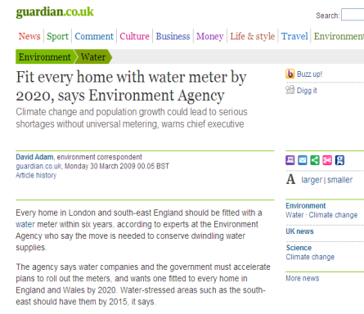  Why would the Environment Agency want to fit every home with a water meter by 2020? Who benefits? How?  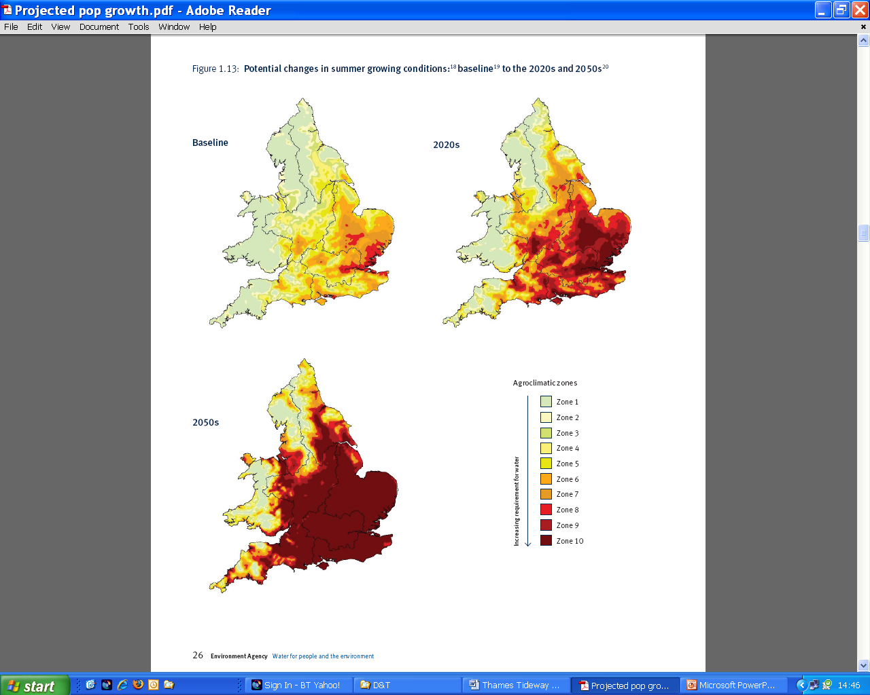  The information in slide 11 is complex but it helps to show students how mathematicians and others work to create future scenarios, producing information to support policy makers. This slide shows four possible scenarios considered by the Environment Agency. Which quadrant implies less water usage?  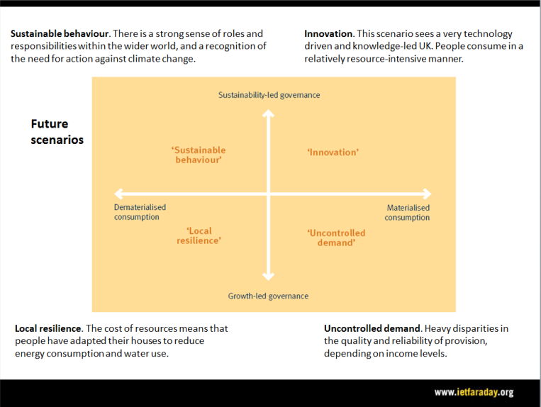  Slide 12 uses these scenarios to consider the predicted impact on water required for homes.  Slide 13 illustrates more scenarios, showing how water usage should be reduced significantly through use of water meters.  Many customers currently have the option of whether or not to have a water meter installed. Only about one in three households currently have a meter fitted although they are common in other European countries.  Students should work in groups to set up their own spreadsheet inspired by the one on the southern water website, inserting formulae to create their own support tool for people considering installing a water meter. Do they agree that ‘on average a household with a water meter will use 10-15% less water than one without’? Students can aim to improve the spreadsheet to allow for other factors, e.g. number of children in the household. Can students improve the way the Water Board gives this information (the detail and presentation)? Students can be encouraged to write to the Water Board with their suggestions. |  |  | The Environment Agency estimates that by 2050 the climate, and therefore the amount of water available, will be very different from today. Slide 8 illustrates their estimate of change in agricultural usage. Why will this change affect water demand and why might users in the home require more water as summers become hotter?  Slides 9 and 10 show the projected change in river flow and how this will affect different regions within the UK.  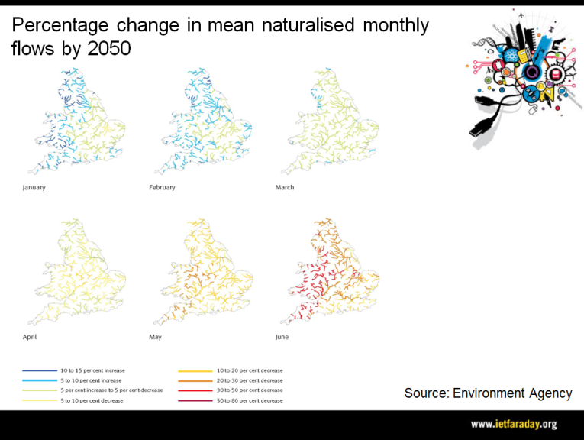  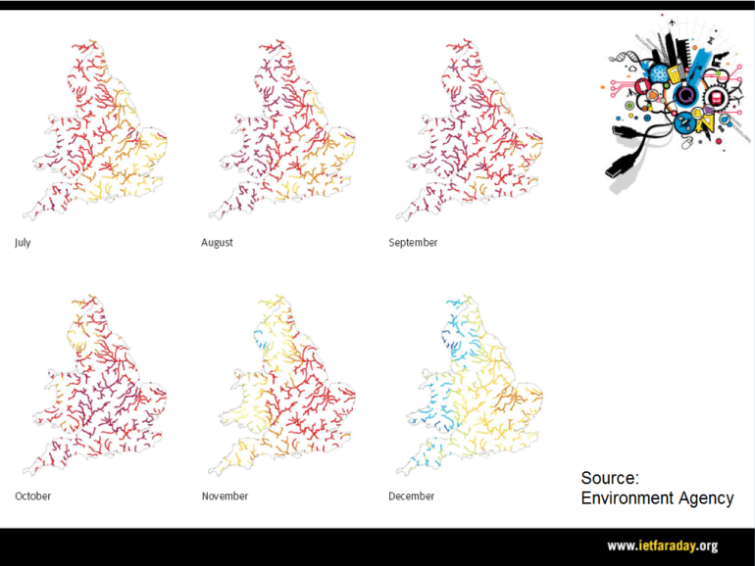
Differentiation
Basic |  |  | Extension
Students should attempt to copy the website produced on an excel spreadsheet. They could also attempt to put a factor into their equations (using the information on slide 12) that will model how usage will change over time. |  |  | - How helpful is the summary of projected costs given by the Water Board? How well does the projection fit with the water bills for the students’ homes?  - Other uses of water include car washing. How do commercial car washing plants recycle their water?
Resources |  |  | Required files
- Projector/Whiteboard |  |  | Sewage Tunnels (Presentation)  Less Water Challenge (Worksheet)  Tomorrows Water Challenge (Worksheet)  Discover More: Running Water (Handout)
Additional websites
- How much water do you use?: http://www.uswitch.com/water/how-much-water-use/

Related activities (to build a full lesson)
Prior Work (Optional)  - ACTIVITY: Sewage Tunnels  - Use of excel formulae  Starters (Options)  - VIDEO: Pure Water  - ACTIVITY: Clean Water 1  - ACTIVITY: Water conservation  - ACTIVITY: Design to sell  Main (Options)  - ACTIVITY: Clean Water 2  - ACTIVITY: Water consumption |  | Main (cont.)  - ACTIVITY: Design to sell 2  Extension (Options)  - Students attempt to model changes that might occur over time in their spreadsheet  Plenary  - Opportunities within activity for presentations, peer/self assessment  - Reflection on Objectives and PLTS skills used  - Presenting and explaining solutions to the class

The Engineering Context 
- The story Pure Water
- How it works? Reverse Osmosis Purification
- Who makes it work? Shivaji Deshmurk

Curriculum links and PLTS
England  Science  > KS3 1b, 2b, 3c, 3d, 4c, 22d  Design & Technology  - KS3 1e (spreadsheet model), 3d  Mathematics  - KS3 1a, 1b, 1e, 1g, 2a, 2g, 3a, 3b, 3c, 4a, 4d, 4l, 6a, 6h, 6j | Northern Ireland  Technology & Design  (Objective 2) Developing pupils as Contributors to Society  - Explore technical inventions and designs that have met a social need cost-effectively  (Objective 3) Developing pupils as Contributors to the Economy and the Environment  - Identify product needs and pursue sustainable harmonious design solutions in a local outdoor/indoor context  Learning Outcomes  - Show deeper understanding by thinking critically and flexibly, solving problems and making informed decisions, using Mathematics and ICT where appropriate  - Work effectively with others  - Demonstrate self-management by working systematically, persisting with tasks, evaluating and improving own performance  - Communicate effectively in oral, visual (including graphic), written, mathematical and ICT formats showing clear awareness of audience and purpose
Scotland  - Number, Money and Measure, MNU 3-07a, Information Handling, MNU 3-20a | Wales  > 4.1, 4.4, 4.5, 4.6, 4.7, 4.8

Assessment opportunities
- APP – Space and Measure
- GCSE 2012 – Functional Skills/Problem Solving (AO2/AO3)
Personal, learning & thinking skills (PLTS)
> Creative thinker
> Self manager

