Water conservation
Compare water usage within the UK to that of other countries

Subject(s): Science, Design & Technology, Mathematics  Approx time: 30-45 mins |  |  | Key words / Topics:  - estimate  - manipulate numbers  - complex data  - spreadsheet
Suggested Learning Outcomes
- To analyse and interpret a wide range of data
- To gain understanding of mathematical modelling used in the real world to predict unknowns
- To use the mathematical understanding of the students to review, recreate, and possibly improve mathematical information presented by a Water Board
Introduction
This activity continues the theme of water usage developed in the Sewage Tunnels activity but can be delivered independently should the teacher wish. Students estimate how much water they use each day and apply their mathematical understanding to interpret a wide range of complex data to develop their appreciation of why water usage is such an important issue. Finally, students consider how different lifestyles impact on water usage, and why it is important to conserve water.
Purpose
This activity provides an engaging lesson, focusing on the link between water usage at home and the number of people living in their household, as well as comparing the water usage within the UK to that of other countries.
Activity |  |  | Teacher notes
Ask students to look again at their estimates of personal water usage per day, generated during the Sewage Tunnel starter activity. (If the Sewage Tunnel starter activity has not been undertaken, students should start this lesson by working to generate their own estimates).  After watching the Pure Water film, ask for the types of activities that use water in the home and the students’ estimates of how much water is used for each. Show slide 6 from the Sewage Tunnels presentation (shown opposite).  Students use the information given to estimate how much water Americans use on average for each of the activities shown, e.g. toilet flushing is 49 litres (29% of 168 litres, to the nearest integer).  Can students use this data to help inform how much water on average is used per person for toilet flushing, etc. in the UK? Some may suggest using the same percentages with the lower average amount used in the UK. Others may argue that, for example, the number of times a toilet is flushed is not culture dependent, or that without further data such as cistern size it is not possible to extrapolate.  Why might Americans, on average, use more water per person than people in the UK? What about other countries? The amount of water used per person varies widely according to country, and also according to different sources. Another website gives the information displayed on the right which shows American usage at almost double the previous source.  Students can discuss how different lifestyles impact on water usage, and why it is important to conserve water. |  |  | 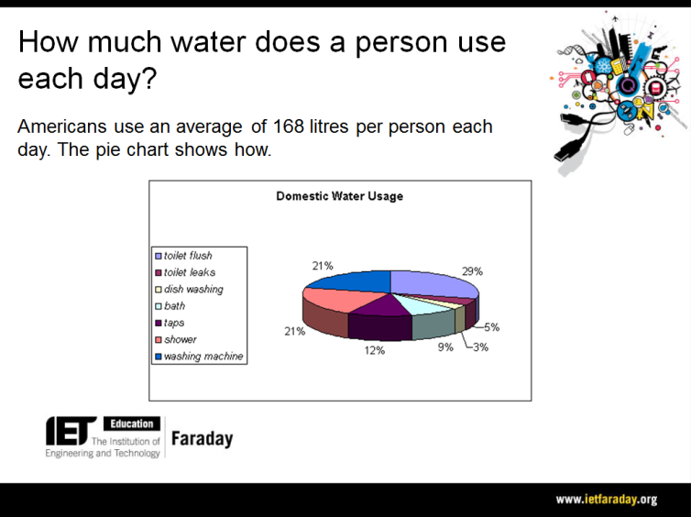  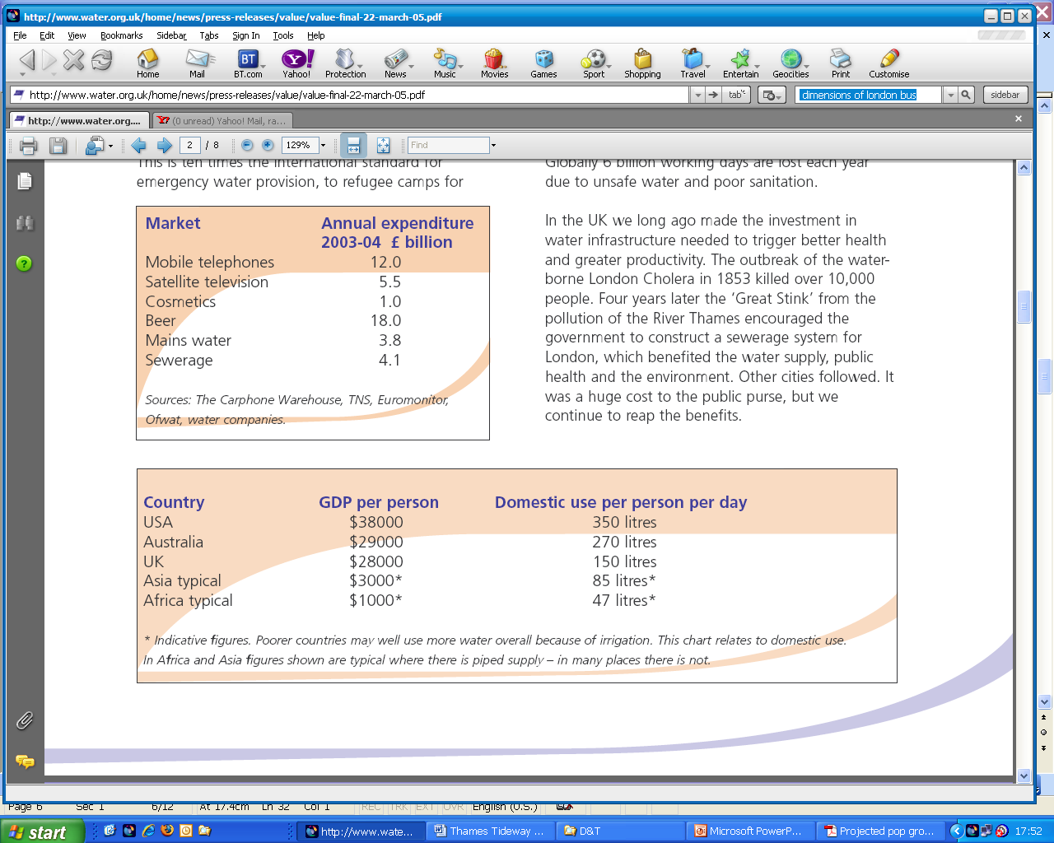  (Source: www.water.org.uk)
Differentiation
Basic |  |  | Extension
The ‘How Much Water? 2’ activity can be used to carry on the learning. This activity focuses on the link between the UK’s current water usage and the predicted increase expected in the future.
It encourages students to think about how mathematicians, policy makers, scientists and others must work together in an attempt to continue to meet the increasing water demands.
Resources |  |  | Required files
 Pure Water film  - Projector/Whiteboard |  |  | Sewage Tunnels (Presentation)
Additional websites
- Environment Agency: https://www.gov.uk/government/organisations/environment-agency
- Water UK: www.water.org.uk
Related activities (to build a full lesson)
Starters (Options)  - ACTIVITY: Clean Water 1  - ACTIVITY: Water conservation  - ACTIVITY: Design to sell  Main (Options)  - ACTIVITY: Clean Water 2  - ACTIVITY: Water consumption |  | Main (cont.)  - ACTIVITY: Design to sell 2  Plenary  - Opportunities within activity for presentations, peer/self assessment  - Reflection on Objectives and PLTS skills used

The Engineering Context
- The story Pure Water
- How it works? Reverse Osmosis Purification
- Who makes it work? Shivaji Deshmurk

Curriculum links and PLTS
England  Mathematics  - KS3 1a, 1b, 1e, 1g, 2a, 4a, 4d, 4l, 6a, 6h, 6j, 9b | Northern Ireland  Technology & Design  (Objective 2) Developing pupils as Contributors to Society  - Explore technical inventions and designs that have met a social need cost-effectively  (Objective 3) Developing pupils as Contributors to the Economy and the Environment  - Identify product needs and pursue sustainable harmonious design solutions in a local outdoor/indoor context  Learning Outcomes  - Show deeper understanding by thinking critically and flexibly, solving problems and making informed decisions, using Mathematics and ICT where appropriate  - Work effectively with others  - Demonstrate self-management by working systematically, persisting with tasks, evaluating and improving own performance  - Communicate effectively in oral, visual (including graphic), written, mathematical and ICT formats showing clear awareness of audience and purpose
Scotland  - Number, Money and Measure, MNU 3-07a, Information Handling, MNU 3-20a | Wales  > 4.1, 4.4, 4.5, 4.6, 4.7, 4.8
GCSE Mathematics  AQA Mathematics  - N12, N14, R9, S2  Edexcel Mathematics  - N12, N14, R9, S2  Eduqas Mathematics  - FN12, FN14, FR10, FS3, HS3  OCR Mathematics  - 2.03a, 2.03b, 3.01b, 12.02a | GCSE Statistics  AQA Statistics  - 3.3.1 C1a

Assessment opportunities
- APP – Space and Measure
Personal, learning & thinking skills (PLTS)
> Effective participator

