Discover mass, volume and density
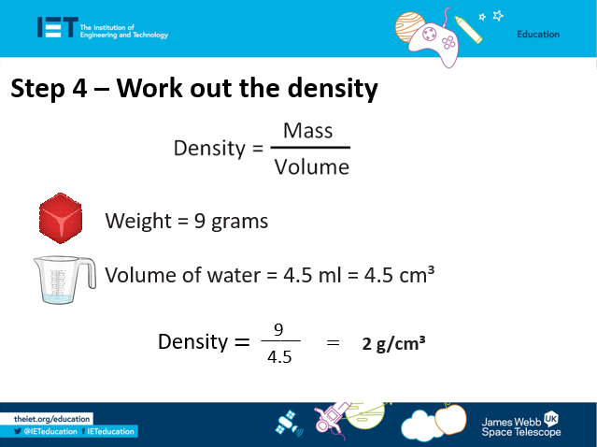

- Complete this worksheet for each object you test.
Object | Weight (g) | Volume (ml) | Density (g/cm³)

- The object with the lowest density: __________________________________________

- The object with the highest density: __________________________________________

