Make a model hydraulic boat lift template
Instructions
- Print off the A4 templates.
- Cut out the templates and glue onto corrugated cardboard ⚠



back

BASE A

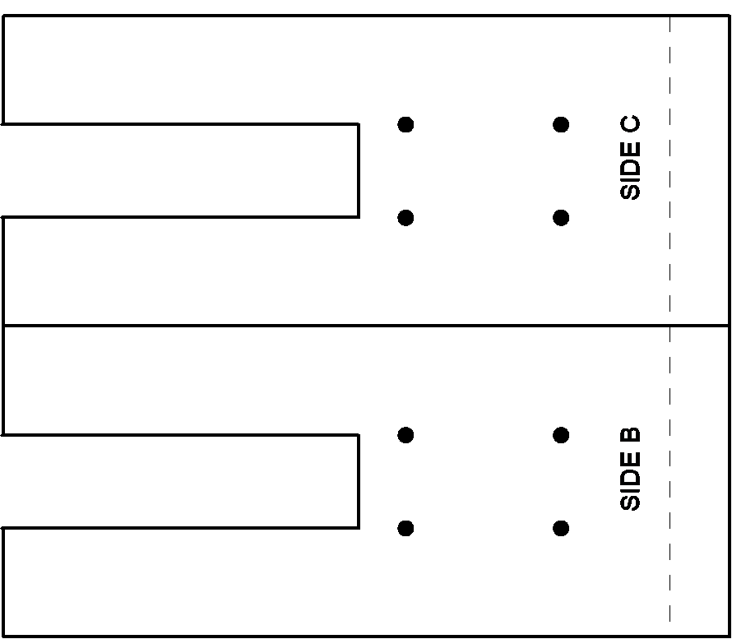
SIDE C

SIDE B

back
BACK E
back
LIFT D

