**The IET**



**Emergency Communications**

**Student Booklet**

**Could you be our engineer….?**

**Contents**

|  |  |
| --- | --- |
| **Section** | **Page number** |
| 1. The context | 3 |
| 2. The scenario | 3 |
| 3. The brief | 4 |
| 4. Schedule for the day | 5 |
| 5. Terrain coordinates and statistics | 6 |
| *Key measurements such as distance between communities*  *And height of mountain* | |
| 6. Materials and resources | 7 |
| 7. Accounting balance sheet | 9 |
| 8. Assessment information and criteria | 10 |
| *How to win points* | |

# The Context

Ease of communication is part of our life, we pick up the phone, turn on the radio, TV or internet to get news and information.

Wifi networks work by using radio signals.

Your phone, TV and radio signals are transmitted by masts we hardly notice. But when all of these are knocked out by natural events - how can communications be restored?

# The Scenario

Life was good in the towns of Alpha and Beta. However, this year, increased solar activity brought disastrous weather. The solar activity caused radiation effects that have disrupted electricity supplies and radio signals.

Torrential rain caused flooding and mud slides on the steep mountain slopes. These brought down nearly all the radio and phone network masts and washed away roads and the telegraph poles for phone lines.

As a result of these extreme weather conditions, people in the surrounding communities have been severely affected. Beta in particular has been cut off completely and there is serious concern about their health, welfare and safety of the population.

**All lines are down …**

# The Brief

You are the engineer rescue team based in the town of Alpha which has been relatively unaffected by the extreme weather.

As the engineer rescue team you need to do 2 things (and quickly!)

1. Design and build a prototype that will allow Alpha to send coded messages to town Beta
2. Create a code to send a message from Alpha across the mountains for decoding in Beta.

There is little time to lose, with a helicopter arriving in a matter of hours to transport half of the rescue team to Beta to set up the system for testing.

**Constraints**

* Must include electrical component to achieve full marks.
* Must send the message over a distance of 5 metres under test conditions.
* Practice messages will be provided to test your prototype, however the message you send in the final phase will be unknown to the rescue team.

# 4. Schedule for the day

|  |  |
| --- | --- |
| **0930** | **Introduction to the Challenge** |
| **0945** | **Electrical briefing**   * Health and safety briefing * Electrical circuit activity |
| **1000** | **Role allocation activity** |
| **1020** | **STAGE 1 - Planning and research**   * Brainstorming * Planning and research |
| **1050** | **STAGE 2 - Development and modifications**   * Development and build of prototype and code * Modification of solution |
| **1110** | **Short break** |
| **1120** | **Continued STAGE 2 - Development and modifications**   * Development and build of prototype and code * Modification of prototype and code |
| **1230** | **Lunch - tools down** |
| **1300** | **STAGE 3 - Final build and testing** |
| **1330** | **TRANSPORT ARRIVES**   * Shop closes! * Sell back unused items * Submit accounting sheet to Challenge Leader |
| **1345** | **STAGE 4 - The final test**   * Presentation - Team’s present reflections from Stages 1, 2 and 3 to the Judges * Final test – Demonstration of each team’s communications system using an unknown message |
| **1445** | **Award ceremony**   * Announcement of winning team * Final feedback and evaluation of the day |
| **1500** | **Finish – students depart** |

# 5. Terrain statistics

|  |  |
| --- | --- |
| **Distance between town Alpha and Beta** | 10 kilometres |
| **Elevation - Height of mountain (distance between sea level and summit of mountain)** | 2,500 metres |
| **Depth of mountain base** | 2.5 kilometres |
| **Width of mountain base** | 20 kilometres |
| **Angle of Slope** | 110 degrees |

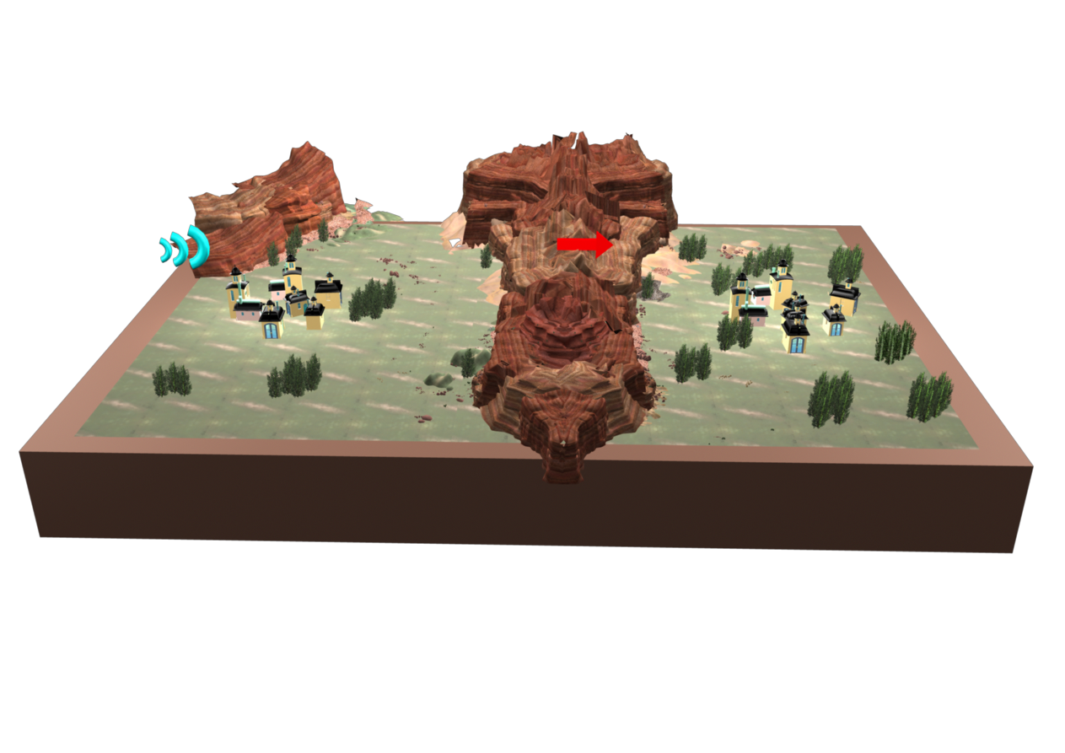

**Alpha**

**Beta**

# 6. Materials resource sheet

**STARTER PACK**

|  |
| --- |
| **Item** |
| 1 x Stick of White Tak  10 x Elastic bands  1.5 x Volt battery D size  1.5 x Volt bulb  1 x Piece x 30cm of black copper wire  1 x Piece x 30cm of red copper wire  Wire strippers  Blue Pen |

**AVAILABLE TO BUY**

|  |  |  |
| --- | --- | --- |
| **Item** | **Unit** | **Cost** |
| Masking tape | 30cm | 5 Faradays |
| Double-sided tape | 30cm | 8 Faradays |
| Plastic cups | 1 cup | 1 Faraday |
| Tin cans | Each | 5 Faradays |
| A4 plain paper | Each | 1 Faraday |
| Coloured card A4 | Each | 1 Faraday |
| Foil 30cm x 30cm | Each | 5 Faradays |
| Neoprene Sheets | Half sheet | 5 Faradays |
| Bubble wrap 25cm x 25cm | Half sheet | 2 Faradays |
| Acetate red 35 x 310mm | Half sheet | 5 Faradays |
| Acetate blue 35 x 310mm | Half sheet | 5 Faradays |
| Mirror 150 x 100mm | 1 mirror | 5 Faradays |
| Straws | 10 straws | 10 Faradays |
| Cardboard tubes | Each | 10 Faradays |
| Thin sponge | Each | 2 Faradays |
| String | Per Metre | 1 Faraday |
| Paper fasteners | 5 fasteners | 1 Faraday |
| Paper clips | 5 paper clips | 1 Faraday |
| Elastic bands | 10 bands | 2 Faradays |
| Steel nail - 10cm | 2 nails | 10 Faradays |
| Binoculars | Each | 30 Faradays |
| Stopwatch | Each | 30 Faradays |
| White Tak | Each | 5 Faradays |
| Polyfoam | A4 size | 10 Faradays |

**ELECTRICAL COMPONENTS**

|  |  |  |
| --- | --- | --- |
| **Item** | **Unit** | **Cost** |
| Copper wire - red | Per metre | 10 Faradays |
| Copper wire - black | Per metre | 10 Faradays |
| Bare copper wire | Per metre | 10 Faradays |
| Croc leads - black | Each | 5 Faradays |
| Croc leads - red | Each | 5 Faradays |
| Croc clips | Each | 5 Faradays |
| Terminal blocks | Each | 2 Faradays |
| 1.5 Volt bulbs | Each | 5 Faradays |
| 3.5 Volt bulbs | Each | 5 Faradays |
| 1.5/3.5 Volt bulb holder | Each | 10 Faradays |
| Batteries - AA size | Each | 2 Faradays |
| Batteries - D size | Each | 5 Faradays |
| Battery holder – 1 D cell | Each | 2 Faradays |
| Battery holder - 3 AA cells | Each | 1 Faraday |
| Watch battery | Each | 1 Faraday |
| Buzzers 3 Volt | Each | 5 Faradays |
| Switches | Each | 5 Faradays |
| Magnet | Each | 5 Faradays |

**AVAILABLE TO HIRE**

|  |  |  |
| --- | --- | --- |
| **Item** | **Unit** | **Cost** |
| STEM Consultancy Time | 5 minutes | 10 Faradays |
| Hole punch | 5 minutes | 5 Faradays |
| Stapler | 5 minutes | 5 Faradays |
| Screwdriver small | 5 minutes | 1 Faraday |
| Calculator | 5 minutes | 10 Faradays |
| Craft Knifes + Technician | n/a | FREE |
| Glue guns | n/a | FREE |

# 7. Accounting balance sheet

# 

**Team………………………………………………….**

You will need to keep an accurate record of all the purchases your team makes.

|  |  |  |  |  |
| --- | --- | --- | --- | --- |
| |  | | --- | | **Materials/services purchased** | | **Quantity** | **Cost** | **Faradays remaining** |
|  |  |  |  |
|  |  |  |  |
|  |  |  |  |
|  |  |  |  |
|  |  |  |  |
|  |  |  |  |
|  |  |  |  |
|  |  |  |  |
|  |  |  |  |
|  |  |  |  |
|  |  |  |  |
|  |  |  |  |
|  |  |  |  |
|  |  |  |  |
|  |  |  |  |
| **Total Faradays remaining** | | |  |

# 8. Assessment information and criteria

|  |  |
| --- | --- |
| **Criteria** | **Marks** |
| 1. Planning and research | 15 marks |
| 1. Development of solutions, highlighting modifications | 20 marks |
| 1. Accounting sheet | 15 marks |
| 1. Presentation of reflections | 15 marks |
| 1. Quality and creativity of communications solution prototype | 15 marks |
| 1. Functionality of communications system encoding/decoding | 15 marks |
| 1. Safe and effective teamwork | 10 marks |
|  | **Total: 100 marks** |

1. **Planning and research (15 marks)**

Using the planning sheet provided, marks will be awarded for:

1. Identification of potential problems, constraints and difficulties **(5 marks)**
2. Development of minimum 2 creative solutions for the prototype **(5 marks)**
3. Development of minimum 2 creative solutions for the code ***(5 marks)***
4. **Development of communication solution (20 marks)**

Using the planning sheet, provided marks will be awarded for:

1. Recording your team’s agreed solution - include the mechanical and electrical components of your device and how they work together **(7 marks)**
2. Identification of the code you will be using **(7 marks)**
3. Note of any changes or modifications you make as a team with the reasons you have changed the design. E.g. materials, sizes, manufacture and ease of use etc. **(6 marks)**
4. **Accounting sheet (15 marks)**

This is a record of all the costs the team has incurred. Marks will be awarded for:

1. Accuracy of expenses ***(10 marks)***
2. Neatness of records ***(5 marks)***

If there is a tie between teams at the end of the day, the winning team will be the one who has the most Faradays remaining.

1. Recording your team’s agreed solution - include the mechanical and electrical components of your device and how they work together (5 marks)
2. Identification what code you will be using (5 marks)
3. Note of any changes or modifications you make as a team with the reasons you have changed the design - think about; materials, sizes, manufacture and ease of use etc. (5 marks)
4. **Accounting sheet (15 marks)**

This is a record of all the costs the team has incurred. Marks will be awarded for:

1. Accuracy of expenses ***(10 marks)***
2. Neatness of records ***(5 marks)***

If there is a tie between teams at the end of the day, the winning team will be the one who has the most Faradays remaining.

1. **Presentation of reflections (15 marks)**

Summarising your learnings recorded at each stage, your presentation should communicate:

1. Why and how you came up with your team’s solution ***(5 marks)***
2. How it could be built in real life ***(5 marks)***
3. How Science, Technology and Maths were used in engineering your solution ***(5 marks)***

There is a maximum of 3 minutes allowed. Taking more time loses marks.

Use your planning and reflection sheet to help.

1. **Prototype (15 marks)**

Your solution will be judged on:

1. Mobility - must be easily transported without connections or elements of the design breaking ***(6 marks)***
2. Quality - must be strong enough to continue to send messages until regular communications are back up and running ***(3 marks)***
3. Creativity - design must be unique ***(3 marks)***
4. Functionality - must function effectively, easily and as planned ***(3 marks)***

Points will be deducted for not including an electrical component.

1. **Code (15 marks)**

The team based in Alpha will be given an unknown message to be sent in code to the team in Beta 5 metres away.

Beta will immediately need to decode the message and hand to the judges for checking.

Marks are awarded for:

1. Creativity of the coding system – must be unique ***(5 marks)***
2. Accuracy of relaying the final message to the Judges ***(5 marks)***
3. Speed – must be easy and efficient to send and receive ***(5 marks)***
4. **Safe and effective teamwork (10 marks)**

Marks are awarded for:

1. How you work as a team in your allocated roles ***(5 marks)***
2. Ensuring that your work station and surrounding area enables safe working and is free from hazards at all times ***(5 marks)***

Points will be deducted for not working as a safe and effective team.